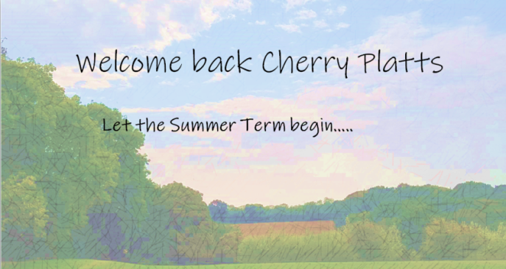

We hope you all had a good Easter with a chance to see family, both at home and online, and enjoy some crafty moments. Thank you to everyone who wished us a ‘Happy Easter’ or sent us photos of cards – these things are very special and valued by us.
The aim this half term is to have a different mix of activities with fewer PowerPoints and more of an emphasis on a project. For this week, there is a short, fun project called ‘The Escape Room’ which has a series of different activities to work through.
Alongside this project, please also try to complete during the week:
- A Maths PowerPoint on converting between different units of metric measures, using place value.
- Daily sessions on TT Rockstars to get your times tables up to speed.
- 2 Grammar PowerPoints: the first focuses on the use of suffixes, which links into your spellings; the second is on noun phrases, which is linked to the English activities below.
- 3 daily English activity packs which look at those noun phrases and poetry.
- Daily reading to an adult, including some time with them asking you questions about the text.
In addition, on the web site, there is a pdf showing the expected progression in grammar and punctuation in Primary Education. This is to help you have an overview of how the work you are doing fits into the Curriculum - hopefully you’ll find it useful.
We have also set up the class on ‘Classroom Secrets Kids’, which has a wonderful range of resources, if you would like to have a look. It is organised by year group, which means that if there is any area that would like to revisit, you can come out of Year 5 and dip into Year 4 to revise the key points. There will be an email giving you your individual user names and passwords.
One final thing before we go, Mrs Walker found this interesting competition that we thought you might like to look at: https://toogoodtogo.co.uk/en-gb/lp/b2c/too-good-to-go-food-waste-poem-competition This is a poetry competition that is open to all primary school pupils and the poem has to be no longer than 16 lines. Entries will be accepted up until midnight on Thursday, May 7th and you might be one of the lucky winners that receive book vouchers for yourself and our school! Here is a link that will refresh your memory on the different styles of poetry: https://www.penguin.co.uk/articles/children/2019/oct/different-types-of-poetry-for-kids.html
Please remember, if you have any questions, then just email them and one of us will aim to respond to you all within the week.
Take care and we look forward to hearing from you all again soon.
Best wishes,
Mrs Kretschmer and Mrs Morris

