Common Exception Words

Family 6: here, there, where, are, were

Commissioned by The PiXL Club Ltd.
October 2018
This resource is strictly for the use of member schools for as long as they remain members of The PiXL Club. It may not be copied, sold nor transferred to a third party or used by the school after membership ceases. Until such time it may be freely used within the member school.
All opinions and contributions are those of the authors. The contents of this resource are not connected with nor endorsed by any other company, organisation or institution.
PiXL Club Ltd endeavour to trace and contact copyright owners. If there are any inadvertent omissions or errors in the acknowledgements or usage, this is unintended and PiXL will remedy these on written notification.

© Copyright The PiXL Club Limited, 2018
Common Exception Words – Family 6

Word 1: here
Meaning: here means in or at this place.
Example: She is here.
Your example: ________________________________________________
Trick: here is her e

Now practise:

Word 2: there
Meaning: there means in that place.
Example: There it is.
Your example: ________________________________________________
Trick: here, there and everywhere

Now practise:

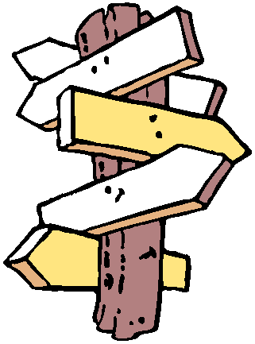
Word 3: where
Meaning: where means in what place.
Example: Where are you?
Your example: ________________________________________________
Trick: where is it? Here!

Now practise:

Word 4: are
Meaning: are means more than one thing lives or exists.
Example: We are here.
Your example: ________________________________________________
Trick: ar e

Now practise:

Word 5: were
Meaning: were means more than one person or thing used to live or exist.
Example: They were here yesterday.
Your example: ________________________________________________
Trick: we were

Now practise:

