Number- Multiplication and Division – Sheet 2
- Establish whether pupils are able to connect division facts with finding fractions of numbers and quantities e.g.
- ¹/₃ of 24 is equivalent to 24 ÷ 3.
- ⁴/₅ of 35 is equivalent to finding 35 ÷ 5 and multiplying the answer by 4.
- Establish whether pupils are able to use factors to help them work out division calculations.
- e.g.90 ÷ 6 by dividing 90 by 3 and dividing the resulting quotient by 2.
- The perimeter of an equilateral triangle is 120 cm. How long is each side?
- Which numbers less than 100 have exactly three factors?
- What number up to 100 has the most factors?
- The sum of four even numbers is a multiple of 4. When is this statement true? When is it false?
- Can a prime number be a multiple of 4? Why?
- Can you give me a number greater than 100 that is divisible by both 3 and 5. How did you do it?
- What is 0.9 × 4? How did you work this out?
- Multiply 7 by 0.6.
- Divide 4.8 by 6.
- What is 4 × 0.7? How do you know?
- 0.15 ÷ 3 =
- What number multiplied by 8 equals 4.8?
- What multiplication and division facts do you know, or can you derive, with an answer of 5.6?
- What could the missing numbers be? × = 3.2
Can you think of several pairs of numbers that would work?
- Solve 2.8 ÷ = 0.4.
- My pencil is 9.2 cm long. My desk is 6 pencil-lengths wide. How wide is the desk, in centimetres?
- Six packets of crisps cost £1.20. How much does each packet cost in £s?
- How many different multiplication and division facts can you find, using what you know about 72? What if you started with 7.2? 0.72?
- The answer to a multiplication or division calculation is 0.56. What could the calculation be? How many possibilities can you find?
- Are any of the following incorrect?
0.7 × 0.8 = 5.6
8 × 0.8 = 6.4
56 ÷ 0.7 = 8
Explain why and how you know, using words or diagrams.
- Establish whether pupils are able to connect division facts with finding fractions of numbers and quantities e.g.
- ¹/₃ of 240 is equivalent to 240 ÷ 3.
- ⁴/₅ of 350 is equivalent to finding 350 ÷ 5 and multiplying the answer by 4.
- How many £10 notes are in £120, £1200? How many £1 coins, 10p coins, 1p coins?
- Tins of dog food at 42p each are put in packs of 10. Six packs are put in a box. How much does one box of dog food cost? 6 boxes? 12 boxes? Etc.
- My pencil is 9.2 cm long. My desk is 6 pencil lengths wide. How wide is the desk in centimetres?
- Find a number whose double lies between 1.3 and 1.4.
- The answer to a multiplication calculation is 0.56. What could the calculation be?
- A girl worked out the cost of eight bags of apples at 47p a bag. Her answer was £4.06. Without working out the answer, say whether you think it is right or wrong.
- Explain how you would do this multiplication by using factors, e.g. 5.8 × 40
- What clues do you look for when deciding if you can do a multiplication mentally? E.g. 5.8 × 40.
- Give an example of how you could use partitioning to multiply a decimal by a two-digit whole number, e.g. 5.3 × 23.
- Discuss the relationship between division and fractions: relate finding 1⁄3 of 24 to 24 ÷ 3
- Find fractions of numbers and quantities, e.g. ‘What is 4⁄5 of 35?’
- I divide a four-digit number by 100. The answer is between 70 and 75. What could the four-digit number be?
- Tom says: ‘If I divide a four-digit number by 1000 it always has a number after the decimal point.’ Is he right? Explain your answer.
- The perimeter of an equilateral triangle is 12 cm. How long is each side?’
- How do you know if a number is divisible by 6?
- Is there a quick way to check if a number is divisible by 25?
- The quotient is 5. Make up some questions. How did you go about devising these questions?
- 73.6 ÷ 3.2 = 23. Explain how you can use this to devise calculations with the same answer.
- Solve missing number problems such as 4.8 x = 43.2
- 611 is the product of two prime numbers. One of the numbers is 13. What is the other one?
- Three bars of chocolate cost 90p. How much would six bars cost? And 12 bars?
- There is space in the car park for 17 rows of 32 cars. How many cars can park?
- How many hours are there in one year?
- Show me your method for solving this problem:
‘What is the total mass of 235 screws each weighing 6 grams?’
What approximations did you make? Explain how you worked out the answer.
- Here is a multiplication calculation with some missing numbers.
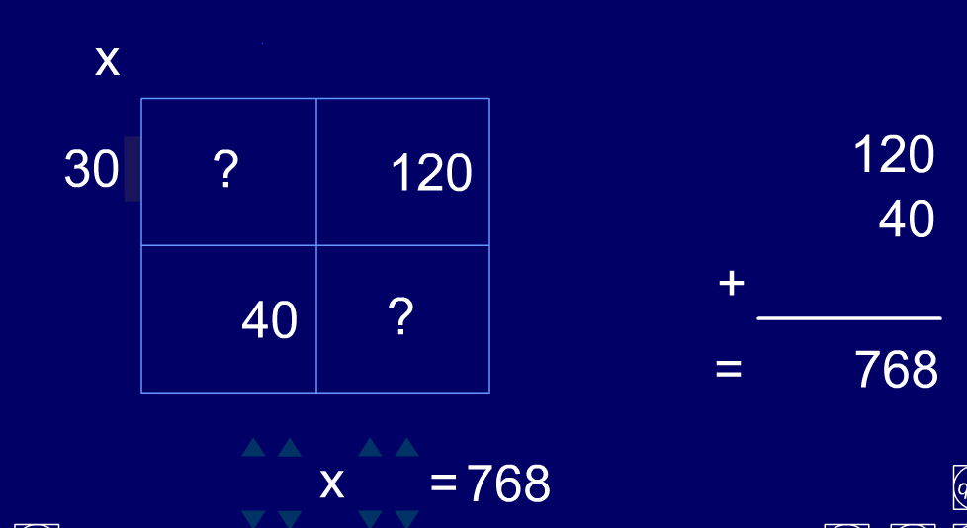

What is the calculation?
Explain how you worked it out.

