Common Exception Words

Family 8: love, come, some, one, once, money

Commissioned by The PiXL Club Ltd.
October 2018
This resource is strictly for the use of member schools for as long as they remain members of The PiXL Club. It may not be copied, sold nor transferred to a third party or used by the school after membership ceases. Until such time it may be freely used within the member school.
All opinions and contributions are those of the authors. The contents of this resource are not connected with nor endorsed by any other company, organisation or institution.
PiXL Club Ltd endeavour to trace and contact copyright owners. If there are any inadvertent omissions or errors in the acknowledgements or usage, this is unintended and PiXL will remedy these on written notification.

© Copyright The PiXL Club Limited, 2018
Common Exception Words – Family 8

Word 1: love
Meaning: love means to have great affection for.
Example: I love my cat.
Your example: ________________________________________________
Trick: o how I love that

Now practise:

Word 2: come
Meaning: come means to move towards something.
Example: Come to my house.
Your example: ________________________________________________
Trick: o come with an e

Now practise:

Word 3: some
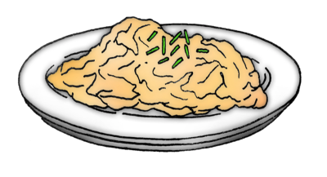
Meaning: some means a certain amount.
Example: I want some dinner.
Your example: ________________________________________________
Trick: come and have some

Now practise:

Word 4: one
Meaning: one means a single thing.
Example: There is just one left.
Your example: ________________________________________________
Trick: one is on the e

Now practise:

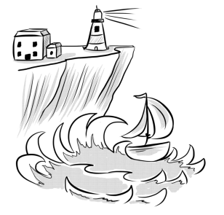
Word 5: once
Meaning: once means one time.
Example: I was here once before.
Your example: ________________________________________________
Trick: once on the c e

Now practise:

Word 6: money
Meaning: money means the notes and coins used to buy things.
Example: I got some money for my birthday.
Your example: ________________________________________________
Trick: mon – e – y

Now practise:

