School Closure Homework Grid Year: 2

Reading | Daily – read for 15 minutes your own book or choose one from Oxford Owl ebooks (suitable for your reading ability) www.oxfordowl.co.uk
Writing | Based on one of the books you have read:  - Character profile sheet  - Recall the story  - Story map  Remember in your writing to focus on: Capital letters, full stops, using interesting vocabulary and neat hand writing
Spelling | Read Write Inc Spelling book – 3 units per week.  Focus on sections – Spelling Zone, Word changers and Dictation  - Week 1 – l and ll; soft c; and suffix y  - Week 2 – Suffix y (2); suffix ly; and n sound kn and gn
Maths | Times Tables Rock Stars x3 per week  Pixl therapy powerpoint x1 per week  - Week 1 – Can interpret tables in different contexts  - Week 2 – Can answer questions about totaling data
Science and the Outside Environment  (Science, PE, Healthy lifestyles, Eco issues and investigation) | Create a poster on how to stay healthy  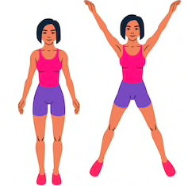 | Create a table showing how many times you can do a range of physical activities in 1minute e.g. hopping, skipping, jumping etc. | Can you find out how pollution affects rivers. Write down 3 facts  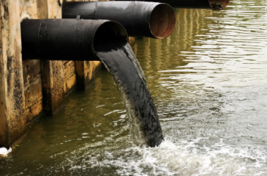 | Write about an animal of your choice. Where does it live? What does it eat? Any other interesting information you can find out.
Humanities and Citizenship  (RE, History, Geography, PSHE) | Re tell the story of Easter – write, draw, act it out. | Write a receipe to create a good friend  Eg. Mix in kindness, Add a pinch of fun etc | Look at a world map. Which country would you like to visit and why? | List castles you, your parents or grandparents have ever visited in the UK. Ask them which was the best and why?
Creative Arts  (Art, Design & technology, Music, Drama & Dance) | Make a 3D object of something you might find at a river. You might want to use junk modeling, salt dough or paper mache etc | Create a picture of some plants in your garden or your house – you can use paint, the computer, collage or draw | Learn a song about plants! Roots, stem, leaves etc or different types of plants.  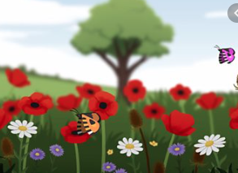 | Do some cooking. Carefully measure out your ingredients.

