Little Peppers – Welcome to the Summer Term Learning from Home!

We hope you all and your families had a lovely Easter break. The sun is shining and we are ready for a new term if not quite what we were expecting!

This email tells you all about what we will be learning over the next few weeks. We still don’t know when we will all be back together again in school but until then here is what we are going to learn.

Reading – please read every day for 15 minutes. Read any book you like but make sure you enjoy it!
If you have run out of books at home why not try e-books on oxford owl. https://www.oxfordowl.co.uk/for-home/find-a-book/library-page/
There are other books you can find online too but they should be suitable for your age and reading ability.

Spelling – this week we would like you to do the following…
Unit 7: igh sound spelt y (page 27-29) and
Unit 8: adding the suffix –ing (page 30 – 32)

Maths – we are going to learn to tell the Time.
First, we want you to make your own homemade clock.
Here are some examples – 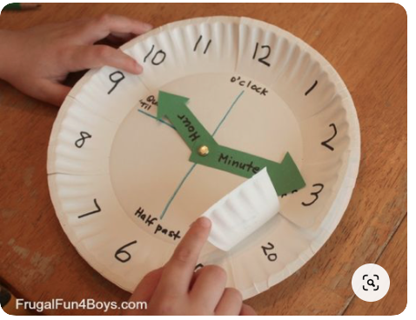
You can follow the instructions on this youtube video https://www.youtube.com/watch?v=uLD9I5rzVQU
or make a simpler one out of a piece of card.
If you don’t have any of these items how about chalk on the pavement and some twigs for the hands of the clock.

Now you have a clock…let’s tell the time.

Use the attached powerpoint this week to recall o’clock, half past, quarter past and quarter to. You need to be able to recognise all of them. You need to be able to draw on a blank clock, read a time given on a clock and write using words eg half past two.

At the end of the week, try your time telling skills with this game (Level 1 only) http://www.ictgames.com/mobilePage/hickoryDickory/index.html
Topic – Around the World
This term all your writing and other learning will be associated with our new topic. Please do it in your School Closure book. If you want to, create a scrapbook at home and put all your topic work in there. Up to you!
Or perhaps an atlas.

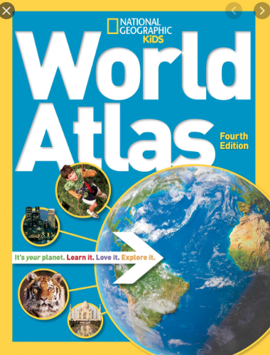
Ideas for topic this week

Have you got a globe at home?
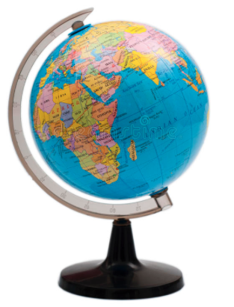

- Have a look at it.
- What can you see?
- What do you already know about the world?
- Can you find out the 7 continents – colour them in on a map and label them.
- Can you now label the 5 oceans of the world

Writing – what facts can you tell us about the world/earth. Write down any fun or interesting facts you can find out in books/online about continents and the oceans. Remember to read the information and then write it in your own words….using your best joined up handwriting!
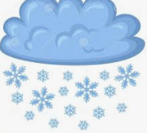 Weather in the world

What do you know about the weather in Antarctica? What is the weather in Africa like? Can you make a poster about weather in two very different places on earth.
Music – can you find some ‘instruments’ around your house to create storm music. Can you make music for a sunny day?
ICT – Google Earth. Look at satellite images of the earth – can you see where the icy areas are? Why is the earth different colours on a satellite map? What do the colours mean?
Science – watch a weather forecast on the TV. Keep a record of the weather at your house for 1 week. You could use weather symbols to record the information.
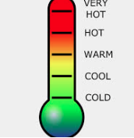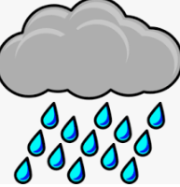
Any questions, just get your parent/carer to email Mr Harris or myself and we will try and help you. Everyone will be doing something slightly different…don’t worry. We want to know what interests you and what you learn from our suggestions.

Time powerpoint
Continents and oceans powerpoint
Continents and oceans worksheet

